WEDNESDAY

Pork or Quorn Sausages
or
Homemade Cheese Pie (V)

Served with:
Creamy Mash Potato or Pasta
Seasonal Veg or Beans.

~ ~ ~

Double Chocolate Cookie
MONDAY

Margarita Pizza (V)
or
Meatballs in a Homemade Tomato Sauce

Served with:
Crispy Potato Balls or Pasta
Seasonal Veg or Beans

~ ~ ~
Rice Crispy Cake
TUESDAY

Cheese Oatcake (V)
or
Homemade Chicken & Leek Pie

Served with:
Hash Brown or Roast Potatoes,
Seasonal Veg or Beans.

~ ~ ~

Marble Cake

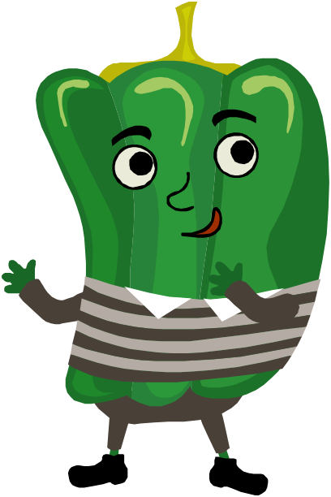

Grid lines

w/c: 05/01/26
w/c: 26/01/26
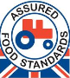
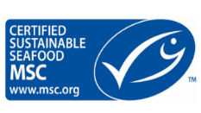
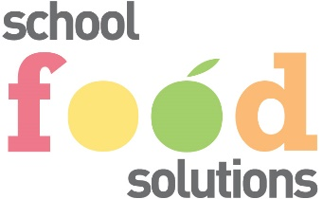
(V) = vegetarian option

(All Menus are Subject to Change)

THURSDAY

Cheese & Tomato Quesadilla Wrap (V)
or
Sausage Roll

Served with:
Herby Potatoes or Pasta
Seasonal Veg or Beans.

~ ~ ~
Fruit Crumble Cake

FRIDAY

Crispy Battered Fish
or
Creamy Korma & Naan Bread (V)

Served with:
Steakhouse Chips or Rice,
Garden Peas or Beans.

~ ~ ~
Chocolate Brownie
LUNCH
MENU
WEEK 1
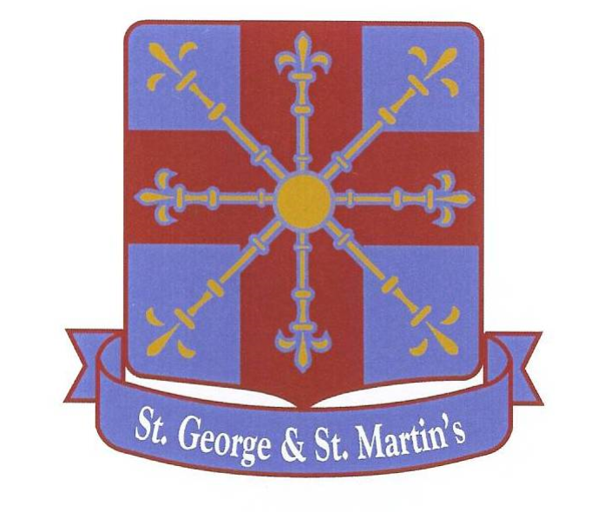

PLEASE NOTE A COPY OF ALL OUR ALLERGEN INFORMATION IS KEPT IN THE KITCHEN OFFICE.

FRESH SALAD, JACKET POTATOES, HOMEMADE SANDWICHES, FRESH FRUIT, ASSORTED FRUIT YOGHURTS AND
CHEESE & BISCUITS ARE AVAILABLE DAILY.

TUESDAY

Cheese Whirl (V)
or
Southern Fried Chicken Wrap

Served with:
Alphabites or Pasta,
Seasonal Veg or Beans.

~ ~ ~
Iced Sprinkle Sponge
WEDNESDAY

Roast Turkey/Quorn fillet
or
Mac N Cheese (V)

Served with:
Creamy Mashed Potato or Pasta,
Seasonal Veg or Beans.

~ ~ ~
Cornflake Slice
MONDAY

Pizza Bagel (V)
or
Homemade Beef Bolognese

Served with:
Crispy Potato Cubes or Pasta,
Seasonal Veg or Beans.

~ ~ ~
Maryland Cookie

w/c: 12/01/26
w/c: 02/02/26

FRIDAY

Fish Star
Or
Creamy Tikka Masala & Naan Bread (V)

Served with:
Steakhouse Chips or Rice,
Steamed Garden Peas or Beans.

~ ~ ~
Choc Chip Shortbread
THURSDAY

Cheese Oatcake (V)
or
Homemade Mince Beef Hotpot

Served with:
Hash Brown or Pasta
Seasonal Veg or Beans.

~ ~ ~
Carrot Cake
LUNCH
MENU
WEEK 2
(V) = Vegetarian option

(All Menus are subject to change)

PLEASE NOTE A COPY OF ALL OUR ALLERGEN INFORMATION IS KEPT IN THE KITCHEN OFFICE.

FRESH SALAD, JACKET POTATOES, HOMEMADE SANDWICHES, FRESH FRUIT, ASSORTED FRUIT YOGHURTS AND
CHEESE & BISCUITS ARE AVAILABLE DAILY.

WEDNESDAY

Homemade Meat & Potato Pie
Or
Pork Quorn Sausage (V)

Served with:
Creamy Mashed Potato or Pasta,
Seasonal Veg or Beans.

~ ~ ~

Maryland Cookie

MONDAY

Margarita Pizza (V)
or
Homemade Chicken Pasta Bake

Served with:
Potato Wedges or Pasta,
Seasonal Veg or Beans.
~ ~ ~

Golden Crunch Cookie

TUESDAY

Breaded Chicken or Quorn Nuggets with Katsu Curry Sauce
or
Cheese Slice (V)

Served with:
Mini Waffles or Rice,
Seasonal Veg or Beans.

~ ~ ~

Chocolate Sponge Cake




FRIDAY

Breaded Fish Finger
or
Sweet Potato Curry & Naan Bread (V)

Served with:
Steakhouse Chips or Rice,
Steamed Garden Peas or Beans.

~ ~ ~
Chocolate Shortbread
LUNCH
MENU
WEEK 3
w/c: 19/01/26
w/c: 09/02/26
THURSDAY

Cheese Oatcakes (V)
or
Vegetable Spring Roll & Sweet Chilli Sauce (V)

Served with:
Hash Brown or Rice,
Seasonal Veg or Beans.

~ ~ ~
Vanilla Cupcake
PLEASE NOTE A COPY OF ALL OUR ALLERGEN INFORMATION IS KEPT IN THE KITCHEN OFFICE.

(V) = Vegetarian option

(All Menus are Subject to Change)

FRESH SALAD, JACKET POTATOES, HOMEMADE SANDWICHES, FRESH FRUIT, ASSORTED FRUIT YOGHURTS AND
CHEESE & BISCUITS ARE AVAILABLE DAILY.

