
School Asthma Policy

School Name: St George and St Martin Catholic Academy

Headteacher/Principal: Mrs Dawn Farmer

Asthma Lead: Mrs Dawn Farmer
Email: dfarmer@sgsmnewman.co.uk

Asthma Champion: Mrs Louise Maddox
Email: lmaddox@sgsmnewman.co.uk

School Nursing Team/Hub Contact: 0808 1783374

Policy Date:09/06/2026

Policy Review Due Date 09/06/2027

Asthma

Asthma is a condition that affects small tubes (airways) that carry air in and out of the lungs. When
a person with asthma comes into contact with something that irritates their airways (an asthma
trigger), the muscles around the walls of the airways tighten so that the airways become narrower
and the lining of the airways becomes inflamed and starts to swell. Sometimes, sticky mucus or
phlegm builds up, which can further narrow the airways. These reactions make it difficult to
breathe, leading to symptoms of asthma.


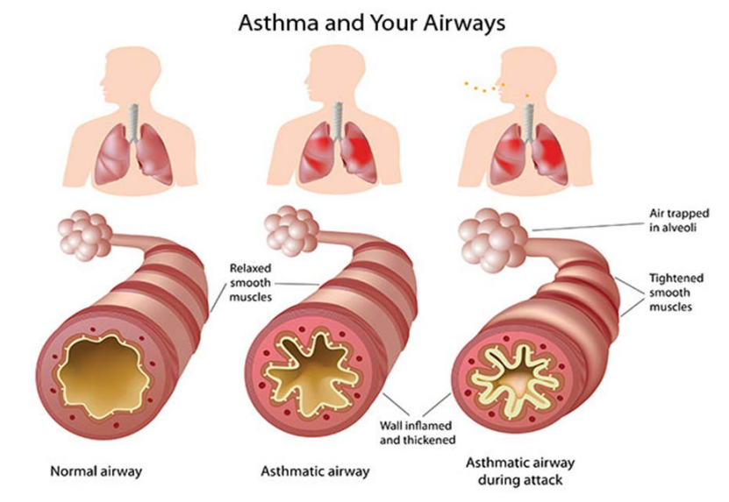

As a school, we recognise that asthma is a common, controllable condition that can be serious if the child has poorly controlled asthma and/or is having an asthma attack. This school welcomes all pupils with asthma and aims to support these children in participating fully in school life. We endeavour to do this by ensuring we have:

- an asthma register
- an up-to-date asthma policy
- an asthma champion
- all pupils with immediate access to their rescue inhaler at all times
- all pupils with an up-to-date asthma care plan
- emergency salbutamol inhaler kits available
- ensured all staff have regular asthma training
- promoted asthma awareness to pupils, parents and staff

Common ‘day to day’ symptoms of asthma

As a school we require that children with asthma have an asthma care plan completed by the child’s parent. These plans inform us of the day-to-day triggers and symptoms of each child’s asthma and how to respond to them individually. We will also send home our own information and consent form for every child with asthma each school year (see appendices 1 and 2). These need to be returned immediately and kept with our asthma register.

However, we also recognise that some of the most common day-to-day symptoms of asthma are:
- Wheeze (a ‘whistle’ usually heard on breathing out)
- Shortness of breath
- Tight chest
- Dry cough

These symptoms are usually responsive to the use of the child’s rescue (usually blue) inhaler and rest (e.g., stopping exercise). As per the Department of Health document (link below), if the child uses the low dose rescue (usually blue) inhaler and responds, they would not usually be required to be sent home from school or to need urgent medical attention.

(https://assets.publishing.service.gov.uk/government/uploads/system/uploads/attachment_data/file/416468/emergency_inhalers_in_schools.pdf)

Asthma Register

We have an asthma register of children within the school, which we update each term. We do this by asking parents/carers if their child is diagnosed as having asthma or has been prescribed a rescue (usually blue) inhaler by a healthcare professional. All Children and Young People (CYP) prescribed a rescue inhaler within the last 12 months but without a formal diagnosis will be included on the register; so that the emergency inhaler and spacer can be made available to them with the consent of their parents/guardian.

When parents/carers have confirmed that their child has asthma or has been prescribed a rescue inhaler we ensure that the pupil has been added to the asthma register and has:
- an up-to-date copy of their asthma care plan completed by a parent/carer (Appendix 1).
- their rescue inhaler in school clearly labelled with their name and an age and ability appropriate spacer.

- permission from the parents/carers to use the emergency salbutamol rescue inhaler and spacer if they require it, and their own inhaler is broken, out of date, empty or has been lost (Appendix 2).

This register will be displayed in the school office, staffroom and medical room alongside emergency procedure instructions. It will also be made available to all staff members including sports and after school club staff (see example register in appendix 3).

Asthma Lead/Champion

This school has an asthma lead and an asthma champion. The asthma lead holds ultimate responsibility for the management of asthma in school and ensures continuity of the Asthma Friendly Schools Programme. It is the responsibility of the asthma champion to manage the asthma register, personal care plans, update the asthma policy, manage the salbutamol inhalers as per the Department of Health Guidance on the use of emergency salbutamol inhalers in schools (https://assets.publishing.service.gov.uk/government/uploads/system/uploads/attachment_data/file/416468/emergency_inhalers_in_schools.pdf) and to ensure measures are in place so that children have immediate access to their inhalers. The asthma champion also ensures that the school maintains its accreditation of the Asthma Friendly Schools programme.

The role of the asthma champion will also include ensuring that all school staff have received regular (annual) training on the management of asthma symptoms via the local NHS School Nursing Team.

Medication and Inhalers

All children with asthma should have immediate access to their rescue (usually blue) inhaler at all times. The rescue inhaler is a fast-acting medication that opens up the airways and makes it easier for the child to breathe.

Some children will also have a preventer inhaler, which is usually taken morning and night, as prescribed by the doctor/nurse. This medication needs to be taken regularly for maximum benefit. Children typically should not bring their preventer inhaler to school as it should be taken regularly as prescribed by their doctor/nurse at home. However, if the pupil is going on a residential trip, we are aware that they will need to take both inhalers (and other prescribed asthma medication) with them so they can continue taking their inhalers as prescribed.

Whilst we recognise that children may need supervision and support in taking their inhaler, school staff are not required to administer asthma medicines to pupils. However, many children have poor inhaler technique or are unable to take the inhaler by themselves and failure to receive their medication could end in hospitalisation or even death. Staff who have had asthma training and are happy to support children as they use their inhaler, can be essential for the well-being of the child. If we have any concerns over a child’s ability to use their inhaler, we will advise parents/carers to arrange a review with their GP/nurse.

Asthma Care Plans

Asthma UK evidence shows that if someone with asthma uses a personal asthma care plan, they are four times less likely to be admitted to hospital due to their asthma. As a school, we recognise that having to attend hospital can cause stress for a family. Therefore, we believe it is essential that all children with asthma have a personal asthma care plan to ensure asthma is managed effectively within school to prevent hospital admissions. All asthma care plans are updated annually or upon any changes to the child’s condition as advised by parents/carers.

Staff training

The school have committed to ensuring that a minimum of 85% of all staff will receive asthma training, including office staff, lunchtime supervisors and classroom support staff. This training will be provided by the Local NHS School Nursing Team.

It is the role of the asthma champion to maintain a record of all staff who have completed asthma training via the local NHS School Nursing Team and to schedule refresher training for all staff when it becomes due for renewal (annually).

School Environment

The school does all that it can to ensure the school environment is favourable to pupils with asthma. The school has a definitive no-smoking policy. Pupil’s asthma triggers will be recorded as part of their asthma care plans and the school will ensure that pupil’s will not come into contact, where possible, with their triggers.

We are aware that triggers can include:
- Colds and infection
- Dust and house dust mite sensitivity
- Pollen, spores and moulds
- Feathers
- Furry animals
- Exercise, laughing, crying
- Stress
- Cold air, change in the weather
- Chemicals, glue, paint, aerosols, perfume
- Food allergies
- Fumes and cigarette/vape smoke
- Outdoor/traffic air pollution

As part of our responsibility to ensure all children are kept safe within the school grounds and on trips away, a risk assessment will be performed by staff. These risk assessments will establish asthma triggers which the children could be exposed to, and plans will be put in place to ensure, where possible, these triggers are avoided.

Exercise and activity

Taking part in sports, games and activities is an essential part of school life for all pupils. All staff will know which children in their class have asthma and all PE teachers at the school will be aware of which pupils have asthma from the school’s asthma register.

Pupils with asthma are encouraged to participate fully in all activities. PE teachers will remind pupils whose asthma is triggered by exercise to take their rescue inhaler via a spacer before the lesson if this is part of their asthma care plan, and to thoroughly warm up and cool down before and after the lesson. It is agreed with PE staff that pupils who are mature enough will carry their inhaler with them

and those that are too young will have their inhaler labelled and kept in a bag at the site of the lesson. If a pupil needs to use their inhaler during a lesson, they will be encouraged to do so.

There has been a large emphasis in recent years on increasing the number of children and young people involved in exercise and sport, in and outside of school. The health benefits of exercise are
well documented, and this is also true for children and young people with asthma. It is therefore important that the school involve pupils with asthma as much as possible in and outside of school. The same rules apply for out of hours sport as during school hours PE lessons.

School Trips/Residential Visits

No child will be denied the opportunity to take part in school trips/residential visits because of asthma, unless so advised by their GP or consultant. The child’s rescue inhaler will be readily available to them throughout the trip, being carried either by the child themselves or by the supervising adult.

For residential visits, staff will be trained in the use of all the CYP regular treatments, as well as emergency management. It is the responsibility of the parent/carer to provide written information about all asthma medication required by their child for the duration of the trip. Parents must be responsible for ensuring an adequate supply of medication is provided which is clearly labelled with the prescribed instruction. Group leaders will have appropriate contact numbers and a copy of each personal asthma care plan. A school spare rescue inhaler and spacer will be taken on the trip.

When asthma is affecting a pupil’s education

The school are aware that the aim of asthma medication is to allow people with asthma to live a normal life. Therefore, if we recognise that asthma is impacting on their life, and they are unable to take part in activities, tired during the day, or falling behind in lessons we will discuss this with parents/carers, and with consent the school nurse who may suggest they make an appointment with their asthma nurse/doctor. It may simply be that the pupil needs an asthma review, to review inhaler technique, medication review or an updated personal asthma care plan, to improve their symptoms. However, the school recognises that pupils with asthma could be classed as having a disability due to their asthma as defined by the Equality Act 2010 and therefore may have additional needs because of their asthma.

Emergency Salbutamol Inhaler in school

As a school we are aware of the guidance ‘The use of emergency salbutamol inhalers in schools from the Department of Health’ (March 2015) (https://assets.publishing.service.gov.uk/government/uploads/system/uploads/attachment_data/file/416468/emergency_inhalers_in_schools.pdf) which gives guidance on the use of emergency salbutamol inhalers in schools. The emergency inhalers held by a school are considered back-up devices and are not replacements for a child or young person’s own medication as prescribed by their GP.

As a school we are able to purchase salbutamol inhalers and spacers from community pharmacists without a prescription (see appendix 4).

All staff are aware that we have 2 emergency asthma kits, which are kept in the following locations so that they are easy to access in the event of an emergency. Posters are displayed in schools that list the locations these are stored:
- Staffroom KS2 Building
- Main Office KS1 Building

Each kit contains:
- A salbutamol metered dose inhaler with manufacturers information
- At least two spacers compatible with the inhaler
- Instructions on using the inhaler and spacer
- Instruction on cleaning and storing the inhaler
- A checklist of kit contents, inhalers to be identified by their batch number and expiry date, with half termly checks recorded
- Process for emergency/acute asthma attack
- Count it out document
- A list of children permitted to use the emergency inhaler (asthma register)
- A record of administration (ie when the inhaler has been used)
- Asthma Champion name and contact details

Emergency kits are also made available for any off-site activities/excursions and for before/after school clubs of which there are 3 all available in the Main Office KS1 Building.

We understand that salbutamol is a relatively safe medicine, particularly if inhaled, but all medicines can have some adverse effects. Those of inhaled salbutamol are well known, tend to be mild and temporary and are not likely to cause serious harm. The child may feel a bit shaky or may tremble, or they may say that they feel their heart is beating faster.

We will ensure that the emergency salbutamol inhaler is only used by children who have asthma or who have been prescribed a rescue inhaler, and for whom written parental consent has been given.
The school’s asthma champion and team will ensure that:
- On a half termly basis the inhaler and spacers are present and in working order, and the inhaler has sufficient number of doses available
- Replacement inhalers are obtained if expiry is within 2 months
- The plastic inhaler housing (which holds the canister) and spacer has been washed in warm soapy water, air dried and returned to storage following use.
- Before using a salbutamol inhaler for the first time, or if it has not been used for 2 weeks or more, shake and release 2 puffs of medicine into the air
- A record of how many doses have been delivered has been made on the ‘Count It Out’ table as the inhaler only contains 200 metered doses of medication and will continue to spray propellant after that (Appendix 5)
- All emergency asthma kits are accessible to staff at all times. No kits should be locked away.

The inhaler and spacer cannot be reused without thorough cleaning. Following use, the inhaler canister will be removed, and the plastic inhaler housing, cap and spacer will be washed in warm running water and left to dry in air in a clean safe place. The inhaler canister will be returned to the housing when dry and the cap replaced.

The emergency salbutamol inhaler will only be used by children:
- Who have been diagnosed with asthma and prescribed a rescue inhaler
OR
- who have been prescribed a rescue inhaler
AND
- For whom written parental consent for use of the emergency inhaler has been given

The name(s) of these children will be clearly written in our emergency kit(s). The parents/carers will always be informed in writing if their child has used the emergency inhaler, so that this information can also be passed onto the GP.

Asthma Attacks

The school recognises that if all of the above is in place, we should be able to support pupils with their asthma and hopefully prevent them from having an asthma attack. However, we are prepared to deal with asthma attacks should they occur.

All staff will receive an asthma update annually, and as part of this training, they are taught how to recognise an asthma attack and how to manage an asthma attack. In addition, emergency guidance will be displayed in the staff room (see appendix 7).

The Department of Health Guidance on the use of emergency salbutamol inhalers in schools (March 2015) states the signs of an asthma attack are:
- Persistent cough (when at rest)
- A wheezing sound coming from the chest (when at rest)
- Difficulty breathing (the child could be breathing fast and with effort, using all accessory muscles in the upper body)
- Nasal flaring
- Unable to talk or complete sentences. Some children will go very quiet
- May try to tell you that their chest ‘feels tight’ (younger children may express this as tummy ache)

If the child is showing these symptoms, we will follow the guidance for responding to an asthma attack recorded below. However, we also recognise that we need to call an ambulance immediately and commence the asthma attack procedure without delay if the child:

*Appears exhausted *is going blue
*Has a blue/white tinge around lips *has collapsed

In the event of an asthma attack we will:
- Keep calm and reassure the child
- Encourage the child to sit up and slightly forward, loosen any tight clothing

If using a Pressurised Metered Dose Inhaler (pMDI):
- Always use the child’s inhaler with a spacer
- Shake the rescue inhaler and insert the inhaler mouthpiece into the hole in the end of the spacer device
- Put the mouthpiece of the spacer into the child’s mouth and ask them to close their lips around to ensure a good seal or if using a mask place the mask securely over the nose and mouth (spacer with mask is only usually used for a child under 4 years)
- Press the inhaler canister down to release 1 puff of medicine into the spacer and ask the child to breath in and out of the spacer 5 times
- Remove from the child’s mouth/face, wait 30-60 seconds then repeat from step 4 onwards and give another puff (total of 2 puffs now given)
- If there is no improvement after 5 -10 minutes, give a further 2 puffs following steps 4-5 (total of 4 puffs now given)
- If no improvement after 5-10 minutes give a further 2 puffs following steps 4-6 (total of 6 puffs now given)
- Stay calm and reassure the child. If the child has responded allow to sit for 15-20 minutes while we observe them. The child can return to normal activities when they feel better
- If the child has not responded to 6 puffs stay calm, continue to give 1 puff every 30 to 60 seconds following steps 4-6 up to a total of another 10 puffs
- If the child does not feel better or we are worried at ANYTIME call 999 FOR AN AMBULANCE
- If an ambulance does not arrive in 10 minutes give another 10 puffs in the same way and call 999 FOR AN AMBULANCE again

If using a Dry Powder Inhaler:
- Load the dose in the inhaler according to the device instructions
- Ask the child to breathe out completely, but not into the inhaler
- Ask them to tilt their chin up slightly and place the inhaler mouthpiece into their mouth, ensuring a tight seal with their lips
- Ask the child to breathe in quickly and deeply
- Remove the inhaler from the child’s mouth and ask them to hold their breath for 5-10 seconds to allow the medication to settle in their lungs
- Repeat steps 1-5 (total of 2 puffs now given)
- If there is no improvement after 5 minutes, give a further 1 puff/inhalation following steps 1-6 (total of 3 puffs now given)
- If no improvement after 5 minutes give a further 1 puff/inhalation following steps 1-5 (total of 4 puffs/inhalations now given). Continue to give up to a total of 6 puffs/inhalations if required
- Stay calm and reassure the child. If the child has responded allow to sit for 15-20 minutes while you observe them. The child can return to normal activities when they feel better
- If the child has not responded after 6 puffs stay calm, continue to give 1 puff/inhalation up to another 6 puffs (12 puffs/inhalations in total)
- If the child does not feel better or we are worried at ANYTIME call 999 FOR AN AMBULANCE
- If an ambulance does not arrive in 10 minutes give another 6 puffs/inhalations in the same way and call 999 FOR AN AMBULANCE again

Appendix 1
Personal Asthma Care Plan Date:

Name:……………………………………………………………………………………………………………………………………..

Date of birth:……………………………………………………………………………………………………………………….

Allergies:………………………………………………………………………………………………………………………………

Emergency contact:………………………………………………………………………………………………………………..

Emergency contact number:…………………………………………………………………………………………………..

Doctor’s name & phone number:……………………………………………………………………………………………

Class:……………………………………………………………………………………………………………………………………….

What are the symptoms or signs that your child may be having an asthma attack?

Are there any key words that your child may use to express their asthma symptoms?

What is the name of your child’s reliever medicine?

Does your child need help using their inhaler/spacer? (please circle) Yes No

What are your child’s known asthma triggers?

When does your child need to take their reliever medicine? What is the dosage that has been prescribed?

I give my consent for school staff to administer/assist my child with their own reliever inhaler and spacer as required. Their inhaler and spacer are clearly labelled and in date.

Signed:……………………………………………………... Date:……………………………………………..….……………….

Print Name:………………………………………..…..... Relationship to child:…………………….…………………..

NOTE: To ensure good asthma care your child should have an annual asthma review with their GP or Practice Nurse. If your child has not had a review in the last 12 months, please contact your GP practice to make an appointment.

Appendix 2
PARENT/CARER CONSENT FORM
USE OF EMERGENCY SALBUTAMOL INHALER

1. I can confirm that my child has been diagnosed with asthma/has been prescribed a salbutamol inhaler (delete as appropriate)
2. My Child has a working, in-date inhaler, clearly labelled with their name, which will be left at school
3. In the event of my child displaying symptoms of asthma, and if their inhaler is not available or is unusable, I consent for my child to receive salbutamol from an emergency inhaler held by the school for such emergencies

Signed:…………………………………………………………………………………… Date:………………………………………….….

Name (print):………………………………………………………………………………………………………………………..………….

Relationship to child:………………………………………………………………………………..……………………………………..

Child’s Name:…………………………………………………………………………………………..………………………………………

Class:………………………………………………………………………………………………………………………………………………..

Parent’s address and contact details:

………………………………………………………………………………………………………………….

………………………………………………………………………………………………………………….

…………………………………………………………………………….......................................

Telephone:………………………………………………………………………………………………….

Email:………………………………………………………………………………............................

Appendix 3
Asthma Register (Example)

NAME | CLASS | DOB | DIAGNOSIS | OTHER CONDITIONS | PARENT CONSENT RECEIVED | INHALER RECEIVED IN SCHOOL | SPACER RECEIVED IN SCHOOL | CAREPLAN UPDATED
Student 1 | Year 4 | 27 Feb 18 | Asthma | NA | 09 Sep 25 | 09 Sep 25 | 09 Sep 25 | 09 Sep 25
Student 2 | Year 3 | 05 Jun 17 | Asthma | NA | 21 Nov 25 | 05 Sep 25 | 05 Sep 25 | 16 Jan 26
Student 3 | Nursery | 18 Sep 16 | Asthma | Hayfever | 28 Jun 25 | 05 May 25 | 09 Sep 24 | Outstanding
Student 4 | Reception | 27 Dec 16 | Wheeze | Nut allergy | 02 Feb 26 | 06 Jun 25 | 10 Sep 25 | 10 Sep 25
Student 5 | Year 10 | 01 Oct 11 | Asthma | NA | 10 Oct 25 | NA | NA | 05 Nov 25

Appendix 4
Letter to pharmacist for spare inhaler and spacer

Dear Pharmacist,

We wish to purchase Salbutamol inhalers and spacers for use in our school. The Salbutamol inhalers and Spacers will be used in accordance with manufacture’s guidelines and the Human Medicines (Amendment) (No. 2) Regulations 2014, allowing schools to buy salbutamol, without a prescription, for use in emergencies.

Item | Quantity
Salbutamol MDI Inhaler
Spacers
AeroChamber Plus Flow-Vu Anti-Static yellow with facemask under 5 years (Trudell Medical UK Ltd)
AeroChamber Plus Flow-Vu Anti-Static youth 5+ years (Green/blue) with mouthpiece (Trudell Medical UK Ltd)
Disposable Able Spacer Pack x 10 (Clement Clarke)

School

Address

Telephone number

Yours faithfully,

Head Teacher

Appendix 5
‘Count it out’ Table

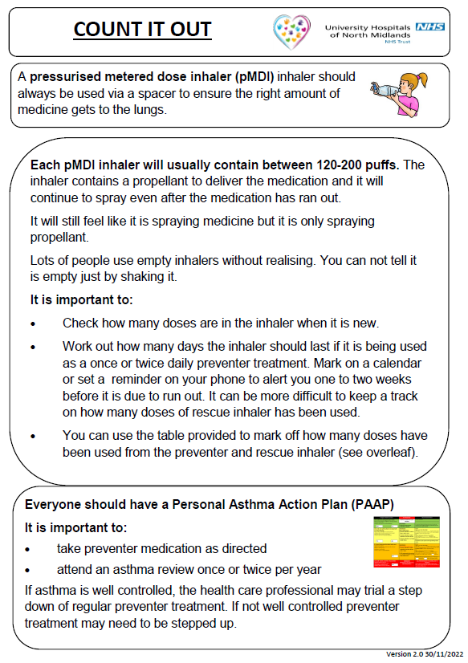

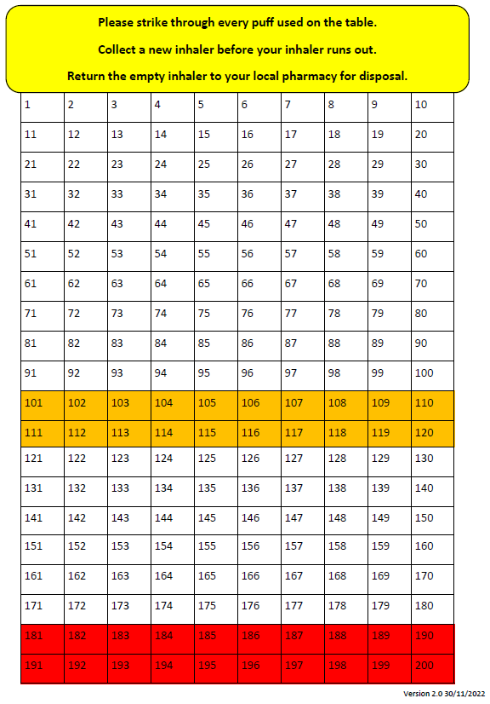

Appendix 6
Instructions for Inhaler Use

A metered dose inhaler should always be used through a spacer device. If the inhaler has not been used for 2 weeks, then press the inhaler twice into the air to clear it.

A Spacer might be:  - Orange  - Yellow  - Blue  - Clear | A spacer may have:  - A mask (for under 5 years)  - A mouthpiece (5 years and over)

Why use a Spacer?
Using a spacer with your Metered Dose Inhaler (MDI) is a more effective way of getting the medication to your lungs. It helps to prevent deposits of inhaled medication in your mouth and stomach.
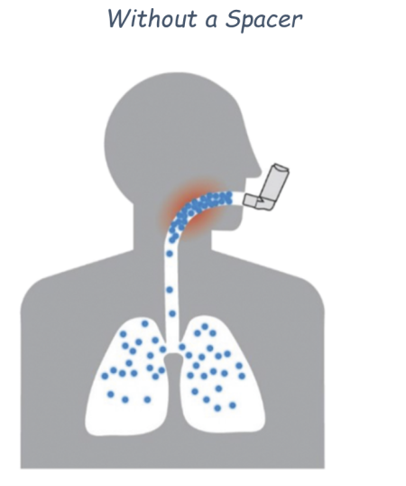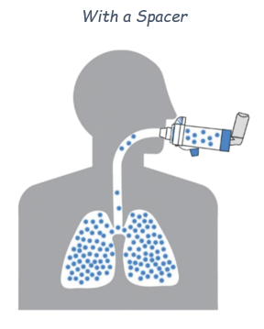

Directions for use
Using a Metered Dose Inhaler (MDI) with a spacer:
- Remove the caps from the inhaler and the spacer (if there is one).
- Shake the inhaler briskly four or five times.
- Insert the inhaler into the spacer.
- Breathe out gently.
- Place the mouthpiece of the spacer into your mouth and create a good seal with your lips.
- Press the inhaler once to release one dose of the medication.
- Take five relaxed breaths in and out, without releasing your lip seal.
- Remove the spacer from your mouth and breathe normally.
- If a second dose is required remove spacer from your mouth, wait approximately 30 seconds and repeat steps 2- 8.
- When finished remove inhaler from spacer and replace lids.

Appendix 7
Guidelines for Emergency / Acute Asthma Attack

In the event of an asthma attack we will:
- Keep calm and reassure the child
- Encourage the child to sit up and slightly forward, loosen any tight clothing

If using a Pressurised Metered Dose Inhaler (pMDI):
- Always use the child’s inhaler with a spacer
- Shake the rescue inhaler and insert the inhaler mouthpiece into the hole in the end of the spacer device
- Put the mouthpiece of the spacer into the child’s mouth and ask them to close their lips around to ensure a good seal or if using a mask place the mask securely over the nose and mouth (spacer with mask is only usually used for a child under 4 years)
- Press the inhaler canister down to release 1 puff of medicine into the spacer and ask the child to breath in and out of the spacer 5 times
- Remove from the child’s mouth/face, wait 30-60 seconds then repeat from step 4 onwards and give another puff (total of 2 puffs now given)
- If there is no improvement after 5 -10 minutes, give a further 2 puffs following steps 4-5 (total of 4 puffs now given)
- If no improvement after 5-10 minutes give a further 2 puffs following steps 4-6 (total of 6 puffs now given)
- Stay calm and reassure the child. If the child has responded allow to sit for 15-20 minutes while we observe them. The child can return to normal activities when they feel better
- If the child has not responded to 6 puffs stay calm, continue to give 1 puff every 30 to 60 seconds following steps 4-6 up to a total of another 10 puffs
- If the child does not feel better or we are worried at ANYTIME call 999 FOR AN AMBULANCE
- If an ambulance does not arrive in 10 minutes give another 10 puffs in the same way and call 999 FOR AN AMBULANCE again

If using a Dry Powder Inhaler:
- Load the dose in the inhaler according to the device instructions
- Ask the child to breathe out completely, but not into the inhaler
- Ask them to tilt their chin up slightly and place the inhaler mouthpiece into their mouth, ensuring a tight seal with their lips
- Ask the child to breathe in quickly and deeply
- Remove the inhaler from the child’s mouth and ask them to hold their breath for 5-10 seconds to allow the medication to settle in their lungs
- Repeat steps 1-5 (total of 2 puffs now given)
- If there is no improvement after 5 minutes, give a further 1 puff/inhalation following steps 1-6 (total of 3 puffs now given)
- If no improvement after 5 minutes give a further 1 puff/inhalation following steps 1-5 (total of 4 puffs/inhalations now given). Continue to give up to a total of 6 puffs/inhalations if required
- Stay calm and reassure the child. If the child has responded allow to sit for 15-20 minutes while you observe them. The child can return to normal activities when they feel better
- If the child has not responded after 6 puffs stay calm, continue to give 1 puff/inhalation up to another 6 puffs (12 puffs/inhalations in total)
- If the child does not feel better or we are worried at ANYTIME call 999 FOR AN AMBULANCE
- If an ambulance does not arrive in 10 minutes give another 6 puffs/inhalations in the same way and call 999 FOR AN AMBULANCE again

Appendix 8
Instructions for cleaning inhalers and spacers

Individual students’ inhalers and spacers should be washed and checked regularly according to instructions; care should be taken not to muddle the components as this could pose a risk to an allergic child. Plastic spacers and inhalers should be washed as follows:

- Take aerosol out of inhaler and take spacer apart.
- Wash inhaler housing and spacer with warm soapy water for 15 minutes.
- Rinse and shake off excess water and leave to air dry.
- Once dry, put back together and place in a material bag or box.
- If the inhaler and spacer have not been used and have been stored correctly in their own sealed packaging, there is no need for them to be washed.

